­­

**Introduction to Social Action**

Case study: One Young World

**WP2 - Social Action Toolkit**

# Social Action Toolkit

### Learning Element 3: Case Study

### 

|  |  |  |  |
| --- | --- | --- | --- |
| **Module Title** | Introduction to Social Action | | |
| **Case Study Title** | **One Young World** | | |
| **Type of resource** | Case Study | **Type of learning** | Self-directed learning |
| **Duration of Activity**  **(in minutes)** | **60 minutes** | **Learning Outcome** | * Understand the definition and purpose of social action. * Identify different forms of social action and their impact on individuals and communities. * Develop an understanding of the importance of youth engagement in social action. |
| **Aim of Activity** | One Young World is a useful case study on social activism and young people because it provides valuable insights into the strategies and approaches that can be used to engage and empower young people to create positive change. By examining the successes and challenges of One Young World, youth workers can learn how to effectively engage and support young people in their own communities to become change agents. The case study also highlights the importance of creating a supportive and collaborative environment that fosters innovation, creativity, and social entrepreneurship among young people. | | |
| **Introduction** | One Young World is a global forum that aims to connect, inspire, and empower young people around the world to create positive social change. Founded in 2009, the organisation brings together young leaders from every country and sector to share ideas, develop leadership skills, and collaborate on innovative solutions to some of the world's most pressing challenges.  One of the primary ways that One Young World encourages young people to do social good is through its annual summit. Each year, thousands of young leaders from around the world come together for a week-long event that includes keynote speeches, workshops, and networking opportunities. The summit provides a platform for young people to share their stories, exchange ideas, and develop practical solutions to issues such as climate change, human rights, and poverty.  At the summit, One Young World also provides delegates with training in leadership and social entrepreneurship. This training is designed to help young people develop the skills they need to create positive change in their communities and beyond. By equipping young leaders with the tools they need to make a difference, One Young World is helping to create a new generation of changemakers who are committed to social good. | | |
| **Challenge** | One Young World has been successful in inspiring young people to do social good by providing them with a platform to connect, learn, and collaborate. The organisation has helped to create a global community of young leaders who are committed to making a difference in the world. By empowering young people to take action on the issues that matter most to them, One Young World is helping to create a more just and sustainable future for all.  In addition to its annual summit, One Young World runs a number of other programs and initiatives that encourage young people to get involved in social causes. For example, the organisation has launched a series of online campaigns to raise awareness about issues such as mental health, gender equality, and sustainable development. It also provides funding and support to young entrepreneurs who are working on innovative solutions to social problems.  As the most international youth conference in the world, One Young World offers a unique chance to connect and network with over 2,000 young leaders from 190+ different countries. You'll have the chance to learn from your peers, share your own initiatives, and even collaborate on new projects.  Young people gain lifelong access to a community of over 15,000 individuals. Being a part of this community, young people will have access to funding opportunities, educational resources, mentorship, and speaking engagements. The in-house community team will remain in touch with young people, keeping them up to date on opportunities to boost their platform and maximize the impact they can have on the world.  One Young World has been successful for several reasons:  **Focus on young people:** One Young World's focus on empowering young people has allowed them to tap into the passion, creativity, and energy of youth. By providing young people with the tools, resources, and support they need to create positive change  **Global network:** One Young World has built a global network of young leaders from over 190 countries. This network provides a diverse range of perspectives, ideas, and experiences, which are essential for tackling complex social issues on a global scale.  **Collaborative approach:** One Young World takes a collaborative approach to social change, emphasizing the importance of partnerships, alliances, and networks. This approach has enabled One Young World to leverage the resources and expertise of a wide range of stakeholders, including governments, NGOs, and businesses.  **Comprehensive support:** One Young World provides comprehensive support to young leaders, including training, mentoring, and funding opportunities. This support helps young leaders develop the skills and knowledge they need to create sustainable social impact. | | |
| **Assignment** | Check out www.oneyoungworld.com and it’s YouTube channel to get a better idea of the way they engage young people.  **Set of questions for reflection:**   1. How might the strategies and approaches used by One Young World be adapted or applied in your own work with young people? 2. How might you collaborate with other organisations or stakeholders to promote social change and activism among young people, as One Young World has done? 3. What steps can you take to provide young people with the tools and resources they need to become effective agents of social change, as One Young World has done through its training and support programs? | | |

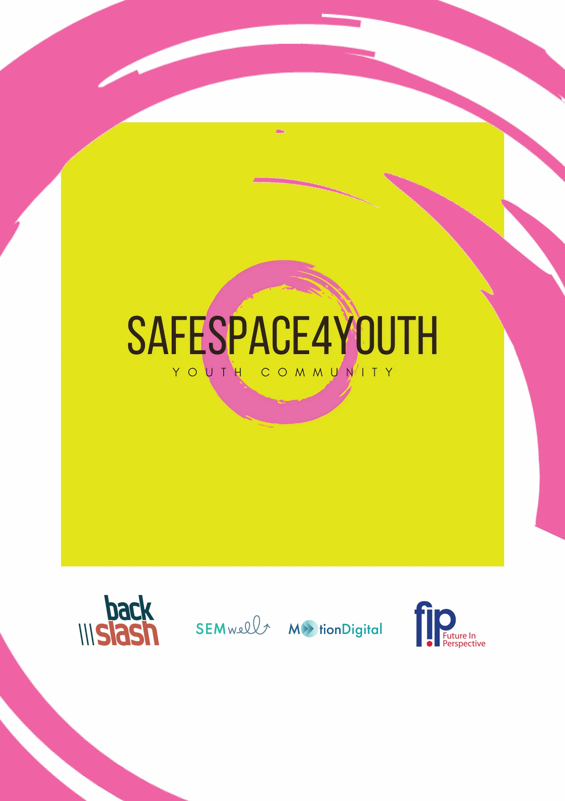 ­­­­

Funded by the European Union. Views and opinions expressed are however those of the author(s) only and do not necessarily reflect those of the European Union or the European Education and Culture Executive Agency (EACEA). Neither the European Union nor EACEA can be held responsible for them. Project Number: 2022-1-CZ01-KA220-YOU-000087166